____________________________________

MyNLRB User Guide

Version 1.0

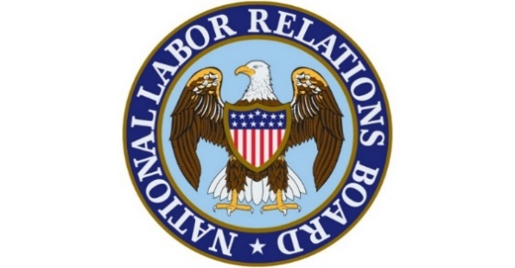

National Labor Relations Board (NLRB)
June 16th, 2021

Prepared By:

____________________________________________________________

Table of Contents
1. Introduction 3
1.1. Purpose 3
2. MyNLRB 3
2.1. Log in Using Login.gov 3
2.2 Dashboard 4
2.3 My Saved Searches 4
2.3.1 How to Save a Search 4
2.3.2 Saved Searches on the Dashboard 6
2.4 My Cases 7
2.4.1 How to Add a Case 7
2.4.2 Case Developments 9
2.5 My Regions 11
2.5.1 Select Default Region 11
2.5.2 Regional News 12
2.5.3 Regional Case Developments 12

1. Introduction

1.1. Purpose
With the “MyNLRB” page, you can display content from various places on nlrb.gov all together on your dashboard. This includes:
- Pulling in information from one or more Regional offices to see the latest news and case-related information
- Saved searches that you frequently use for quicker access
- Being able to navigate directly to one of the many search pages on the site
- The ability to create a list of cases to follow

2. MyNLRB

2.1. Log in Using Login.gov
NLRB’s Public Website uses login.gov to allow you to sign into your account safely and securely.
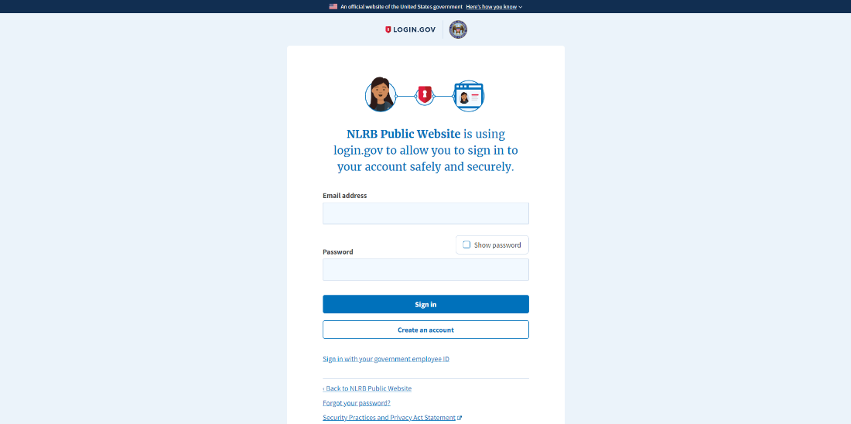

2.2 Dashboard
The MyNLRB dashboard is a tabbed interface where a user can see their saved searches, cases they follow, and regions they follow all in one place.
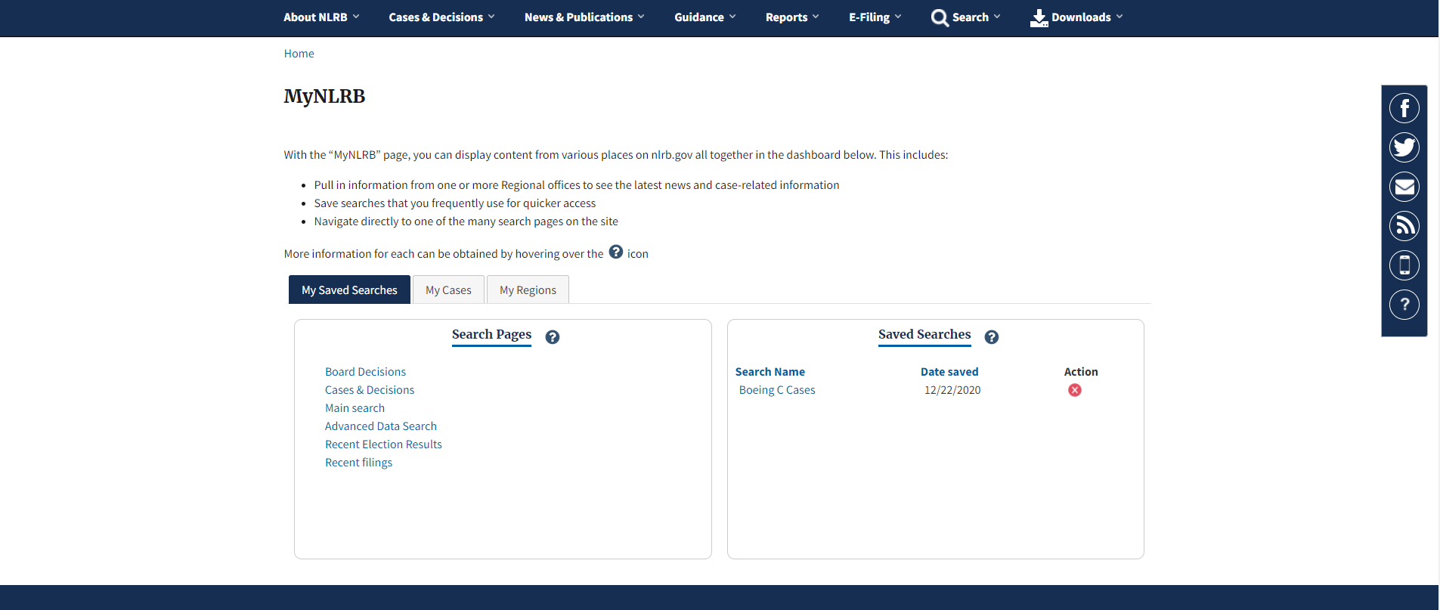

2.3 My Saved Searches

2.3.1 How to Save a Search
- On the main menu find the Search dropdown, to perform a search.
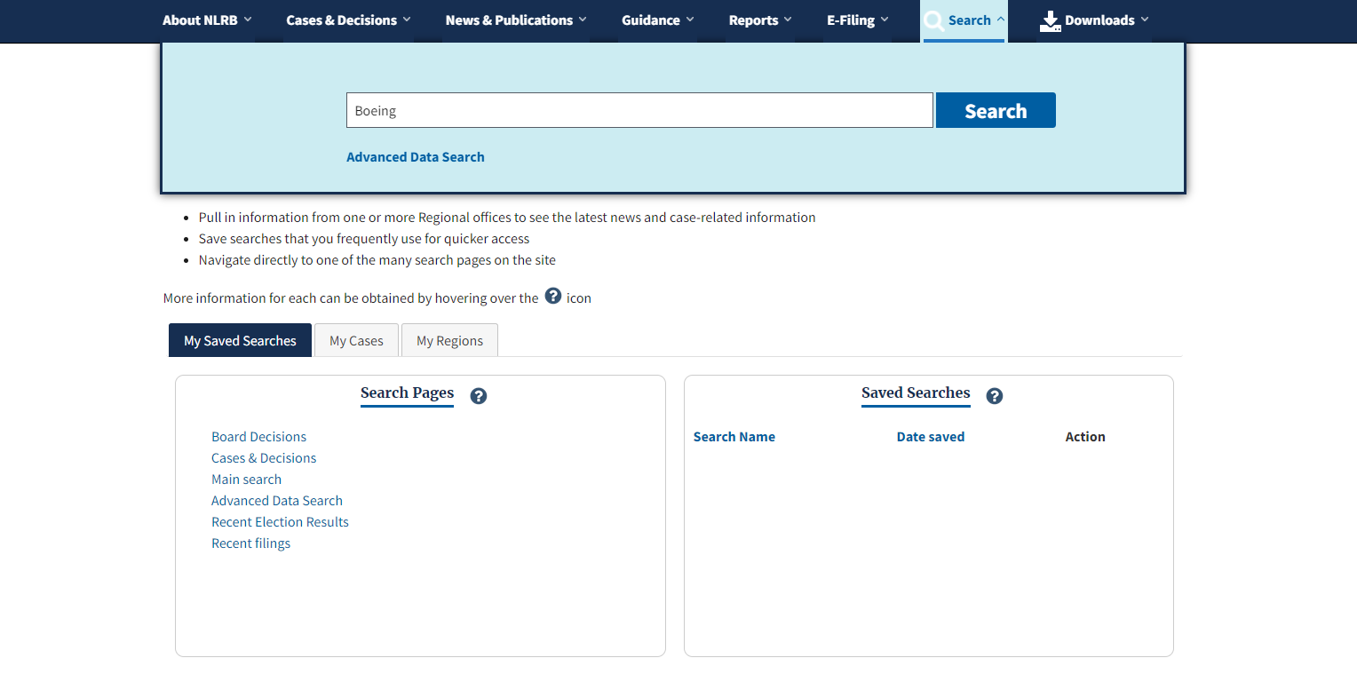
- Add any filters you want, then click the Save Search button at the top of the search page.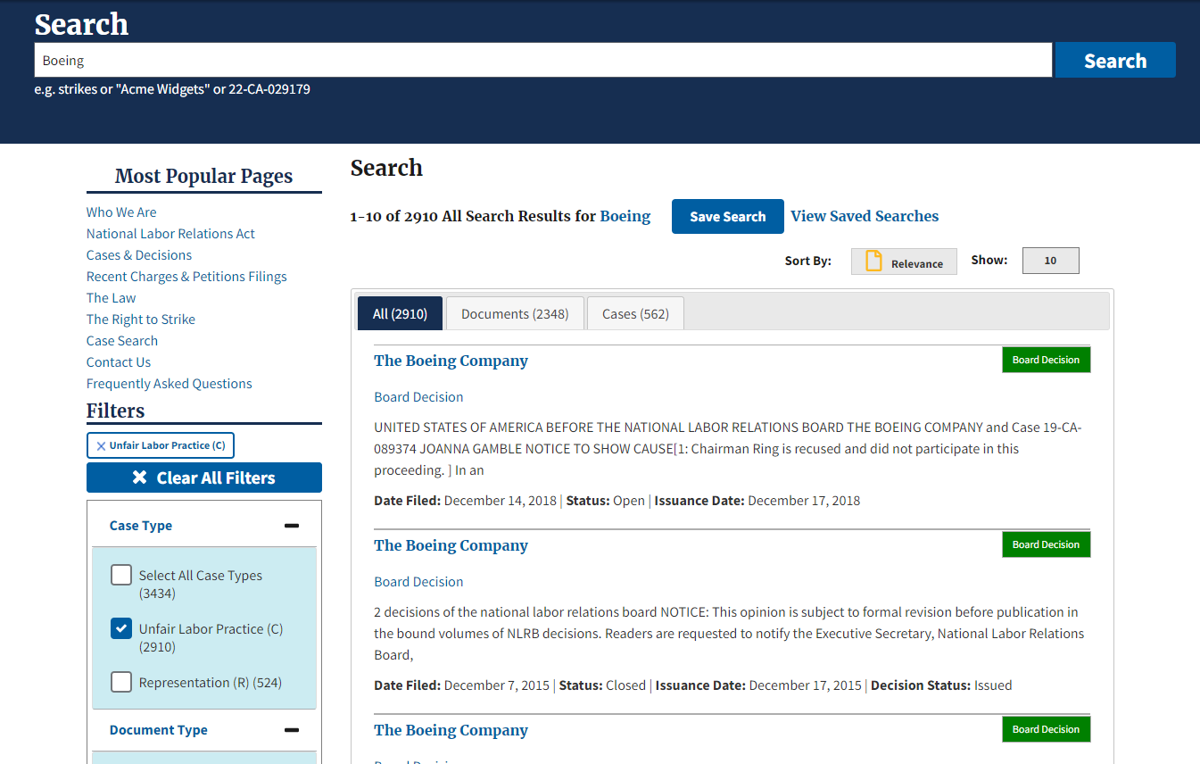

- Enter a Search Name for this given search, then click the Save Search button. You will be given dialog that the saved search was successful. This box will go away on its own.
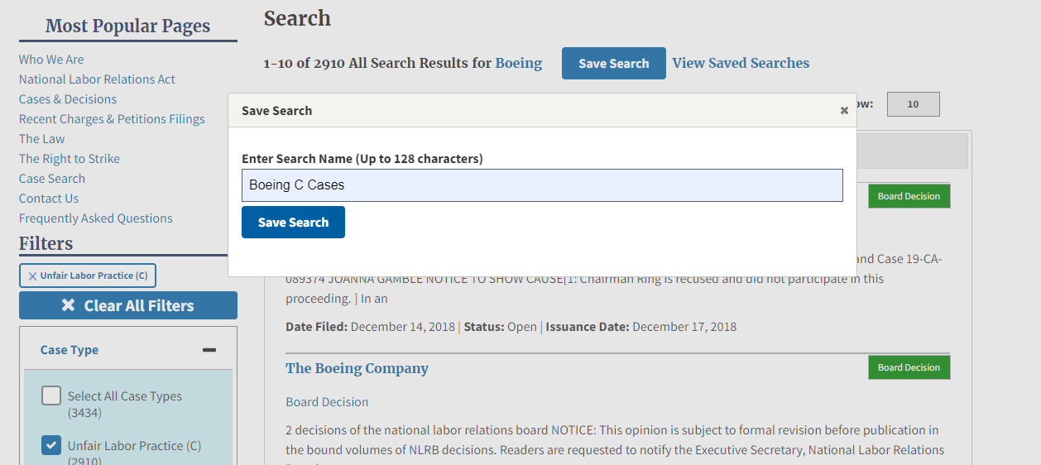

- You will find your saved search on your MyNLRB dashboard. You can now have your frequent searches saved so they can be quickly accessed and rerun.
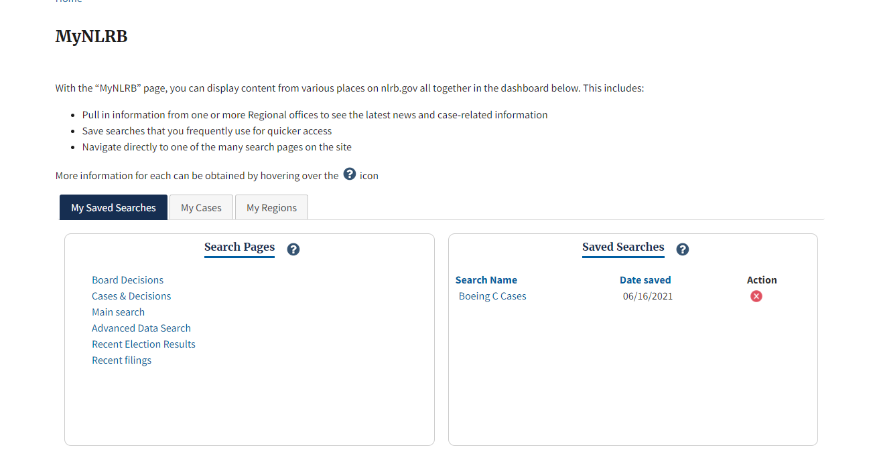

2.3.2 Saved Searches on the Dashboard
There are two sections under the My Saved Searches tab, Search Pages and Saved Searches.
Search Pages shows a list of various pages on the site to search for case and election related information.
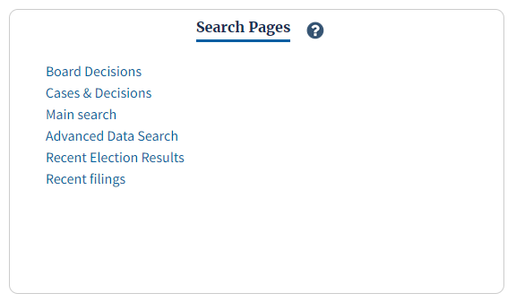

Saved Searches shows a list of search results that are saved to be quickly accessed and rerun. The information provided under this section is the Search Name and the Date each search was saved. You also have an action column where you can click the X button associated with a search if you wish to remove it from your Saved Searches.
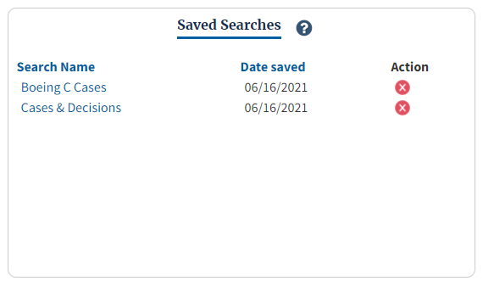

2.4 My Cases
My Case enables users to follow cases. Users will receive email notifications when updates are made to a case that they follow. Users will also see a list of their cases with the latest updates on their MyNLRB dashboard.

2.4.1 How to Add a Case
You can add a case from the Case Page itself or on the MyNLRB dashboard under the My Cases tab.
- On the MyNLRB dashboard – If you know the Case Number of the case you wish to add you can add that case under the My Cases tab. Under Add Case by Case Number, type in the Case Number and Hit Add Case.
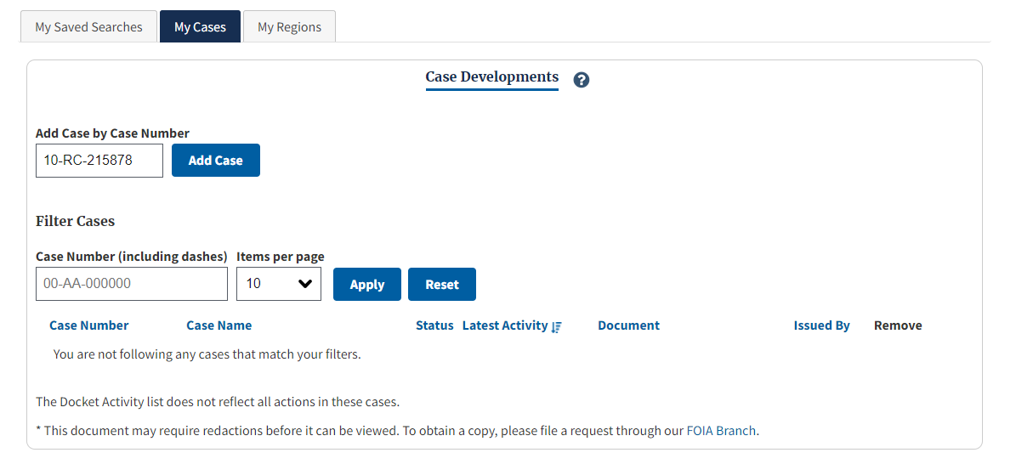
You are now following that case! You can see the information for this case and all your cases listed under the My Cases tab.
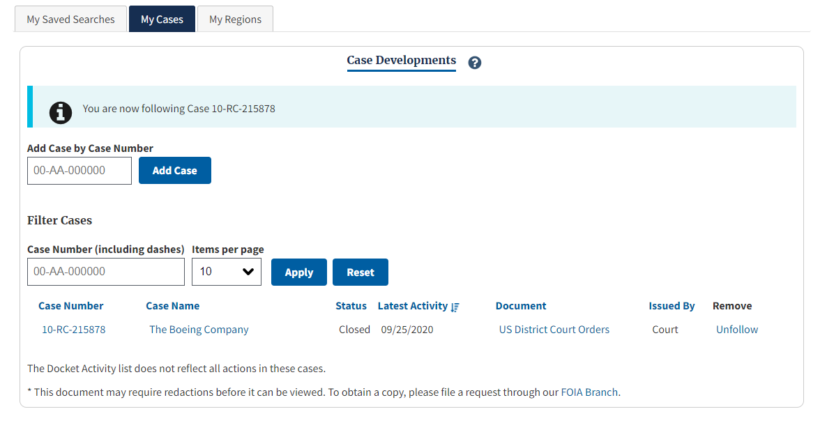
- On the Case Page - You also have the option to add a case on the Case Page itself.
  - Find the case you wish to add.
  - Once you are on the case page, click the blue Follow Button on the top right of the page.
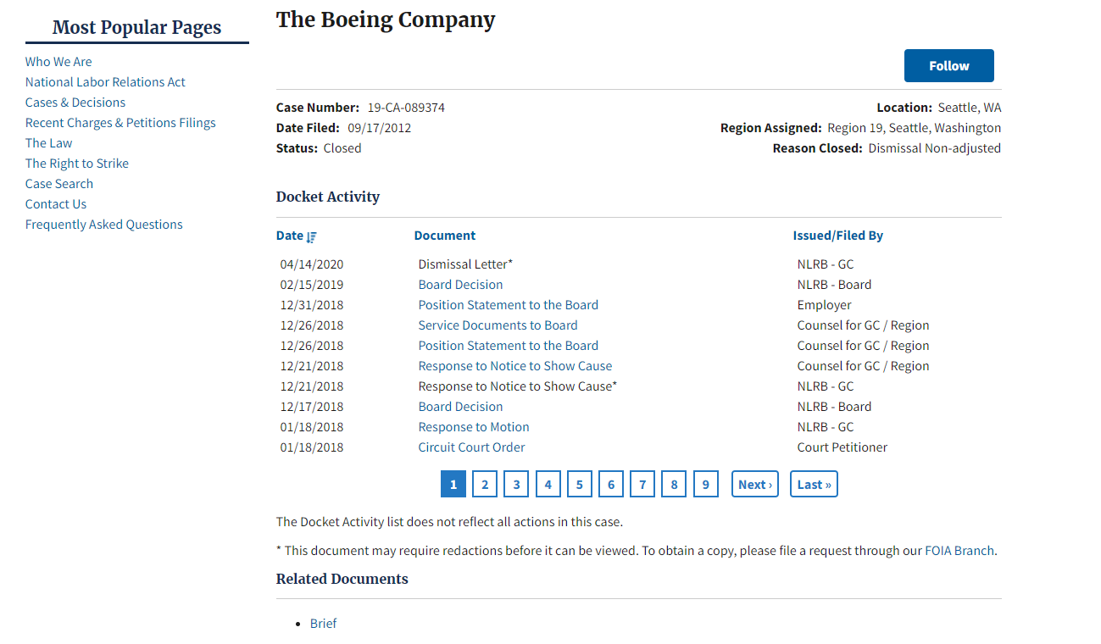

  - The button will turn gray and say unfollow after you click on it. If you wish to unfollow a case from the Case Page, simply click the gray Unfollow button. You will unfollow that case and the button will turn blue again.
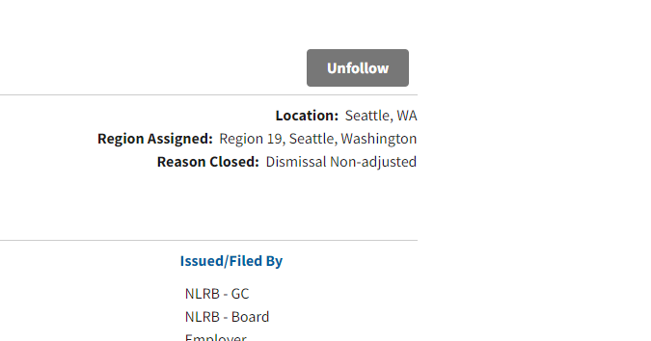

2.4.2 Case Developments
Under the My Cases tab you can view the Case Developments for the cases you follow. The following information is available for each case: Case Number, Case Name, Status, Latest Activity, Document, and Issued By. The list is automatically filtered by Latest Activity, but as a user you can filter this list in many ways. There is also a Remove column where you can easily remove one of your cases by click the Unfollow button.
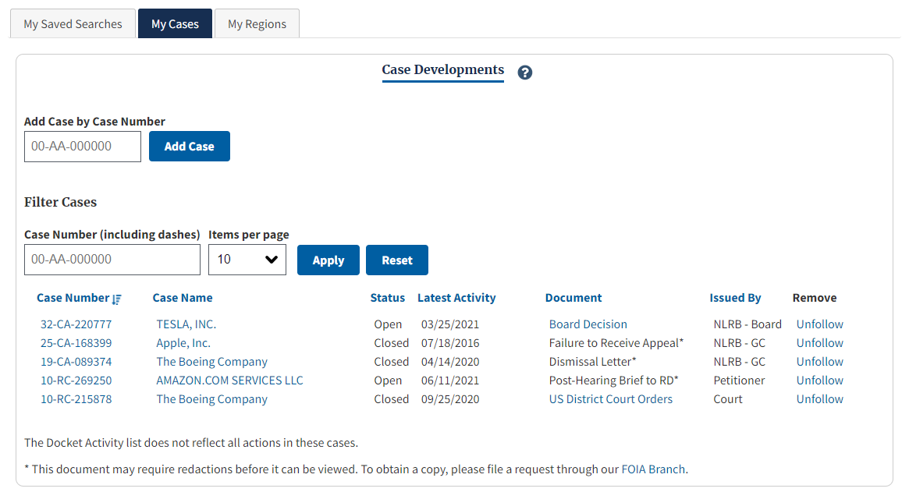

You can narrow down to a specific case by typing in the Case Number, then clicking the Apply button. There is also a Reset button if you wish to see all your cases again.
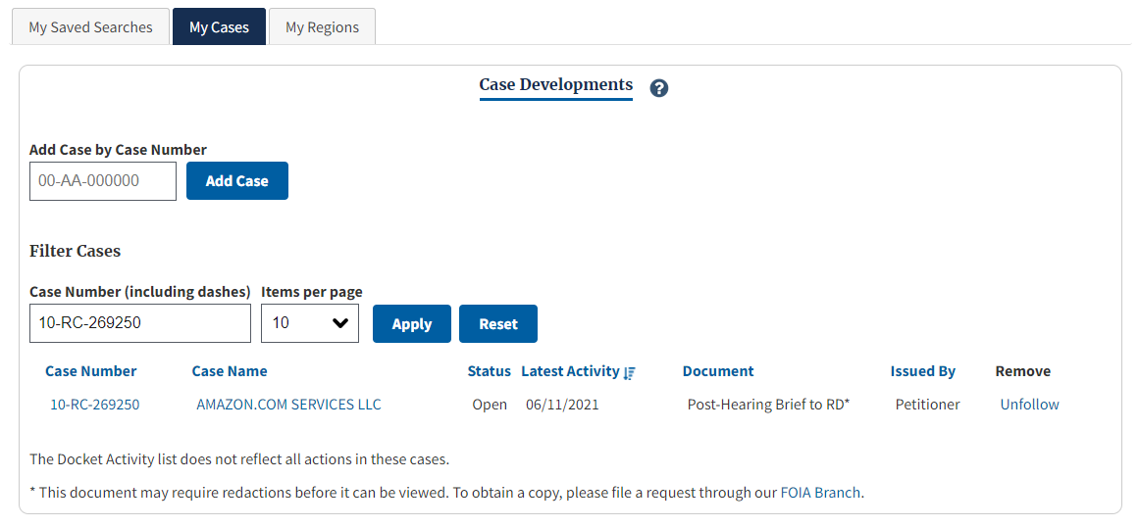

2.5 My Regions
There are three sections under the My Regions tab. Under this tab, you will be able to select default regions as well as view news and case developments from those selected regions.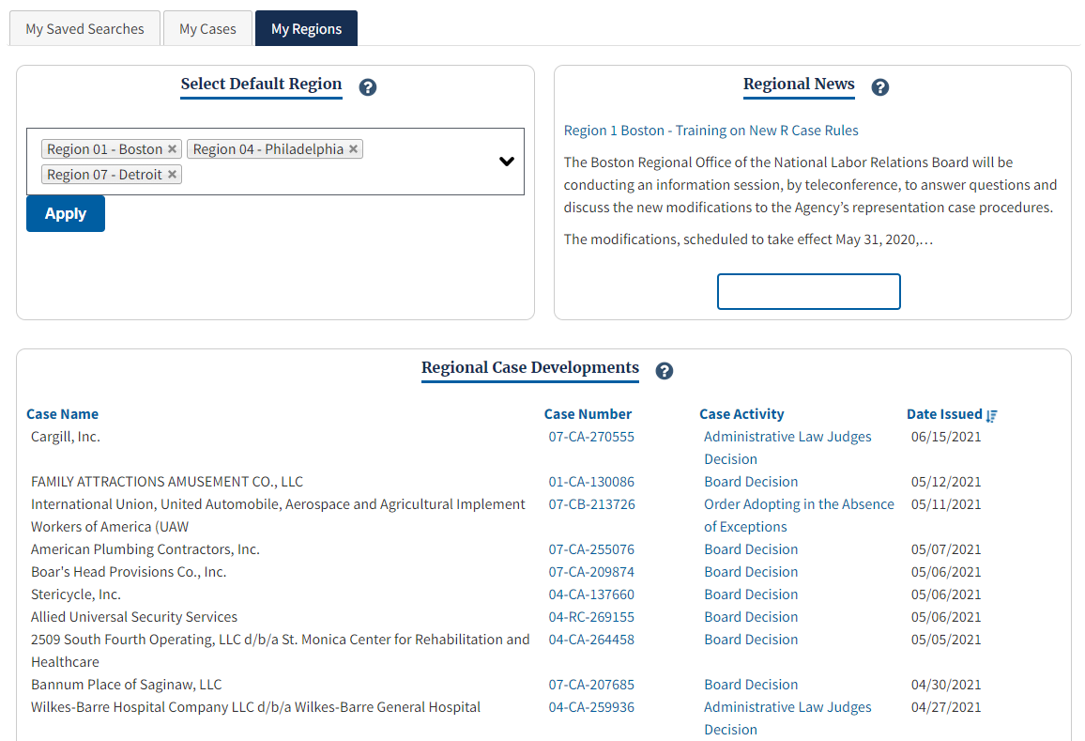

2.5.1 Select Default Region
Use the drop-down list to select one or more default regions. The case-related information and news from the region(s) will be displayed in the other two sections. You can select up to five (5) regions.
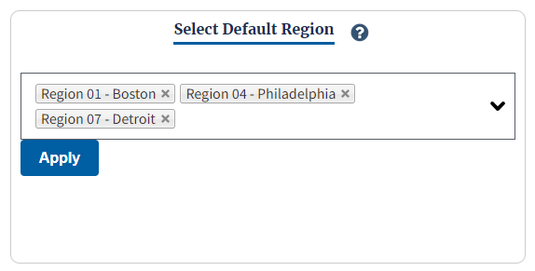

2.5.2 Regional News
Quick access to any news items from the Default Region(s). You can click on the title of the news item to read the entire thing.
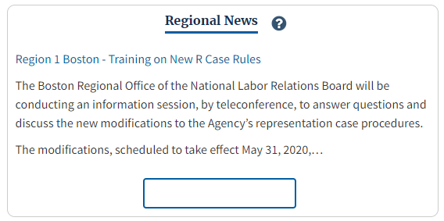

2.5.3 Regional Case Developments
Quick access to cases from the default Region(s). The following information is available for each case: Case Name, Case Number, Case Activity, and Date Issued. The list is automatically filtered by Date Issued, but as a user you can filter by all four categories.
